Essence of Motown Literary
8th Annual Jam & Conference
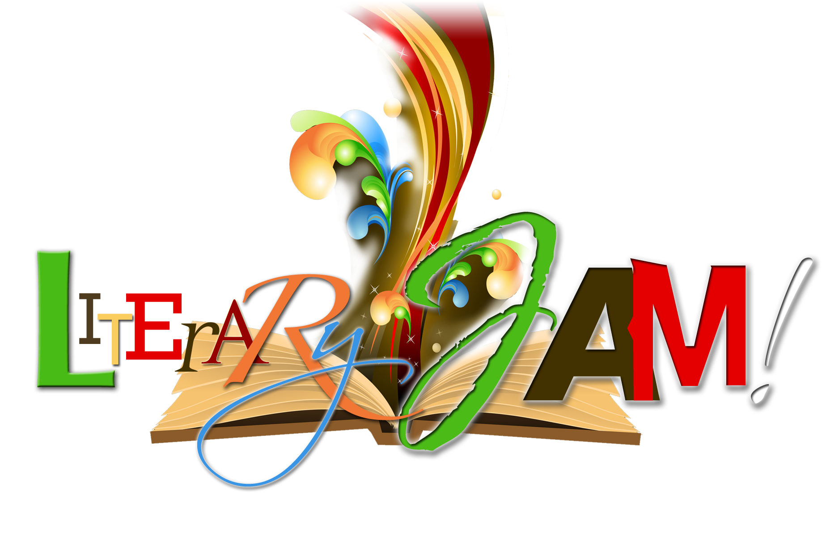
November 11th - 12th, 2011
Detroit Michigan
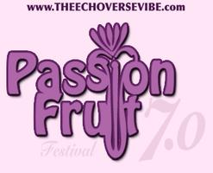
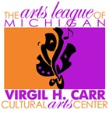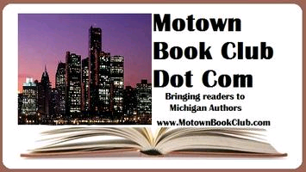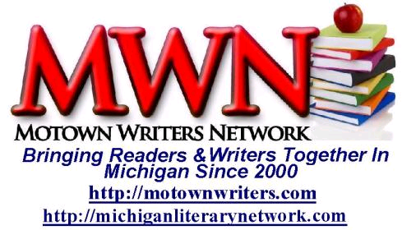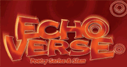

Established in 2000, Motown Writers Network and The Michigan Literary Network was created to strengthen Michigan’s Literary Community. Drawing readers, writers, authors, poets and more together, the networks’ mission is to connect readers to Michigan literary works, educate and connect writers and poets to resources, provide events for authors to showcase their work and a lot more.

Membership is Free to all who are interested (readers and writers) and the networks are there for all to use to help them. Contact us to see what w can do to help you strengthen Michigan’s Literary Network.

We offer a wide range of events, services and promotions for authors, readers, writers and poets. Please peruse our website and then contact us to let us know what we can do for you. Authors and businesses can take advantage and support the network by using our e-blasting service and features to showcase their work and services to our readers and writers.

We’re updating the new site as fast as possible to give it the feel of our old page, but with a lot more organization. To be contacted when our site is updated, please fill out the form on our blog or join our Motown Writers Network Yahoo Group.

Be patient with us, but until then you can always find the resources from our old site on our blog or you can network with other members on our social networks.
Related Websites:
www.MotownWriters.com | www.MichiganLiteraryNetwork.com| www.DetroitLiteraryNetwork.com
WritersGuide2InternetMarketing.com| HubBooks.biz | MichiganMurderAndMayhem.com | MotownMomMusings.com|
SylviaHubbard.com Facebook.com/MichigansLiteraryWorld| Twitter.com/sylviahubbard1 | #motownlit #mwn
Blogtalkradio.com/michiganliterarynetwork| meetup.com/michiganliterarynetwork
Blog: www.MotownWriters.wordpress.com
(If you’d like to guest post, advertise, be a guest on our radio show, volunteer, or host a blog tour on our site, please contact us)
motownwriters@yahoo.com |313.289.8614


www.SylviaHubbard.com
Always available for speaking engagements | 2012 filling up fast | Reserve Your Dates Now
The Essence of Motown Literary Jam & Conference
November 11th – 12th, 2011
Virgil Carr Cultural Center | 311 E Grand River, Detroit, Michigan 48226

www.MotownLiteraryJam.com

* most events are FREE to public

To celebrate the written word in Metro Detroit with every reader and writer around!

Detail Schedule of Events

November 11, 2011

6PM -Literary Free Networking & Open Poetry Mic (spaces are limited) 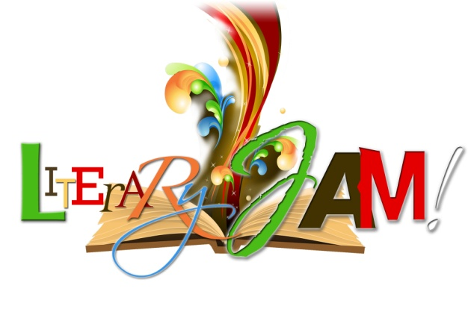WSG InsideOut Teen Poetry and more local poets. Readers, Book clubs & Authors will also be there. Light Refreshments served.

7:30PM - Passion Fruit Poetry & Expression $20 Sensual Poetry for Grown Folks.

November 12, 2011

8AM - Writing, Publishing, Marketing & Promotion Workshops for Authors & Writers $40. Includes lunch keynote speaker, National Bestselling Author & Television Series Writer, Vincent Alexandria. Special workshops will include Social Media for Authors, Ebooking & How to host successful Radio interviews.

11:30AM Free to the Public Marketplace Opens. Authors will be signing books and Vendors will be also present. Authors will be signing books and speaking on their work throughout the day until 4pm.
NOON - Lunch is served for Workshop Attendees

1:30 PM Community Literary Discussion moderated by Ramona Prater hosting an all male panel of community leaders. Topic: How can organizations and citizens help increase literacy in Metro Detroit?
2:30 PM Poetry Panel hosted by Victor "Billionaire" Walker with local featured poets.

3:00PM Special book release party for Versandra Kennebrew, Sylvia Hubbard & Monica Marie Jones

3:30PM Giveaways, Recognition & Awards & more

The Literary Loft | Versandra Kennebrew Intl | EnigmaGraphics | Motown Writers Network | Rolling Out Magazine | Penguin Books | AND Communications | EchoVerse | Detroit Impact Center | 360DigitalBooks | HubBooks

Readers are encouraged to bring books (new or gently used) for donations to our Motown Literacy Project to increase literacy in Metro Detroit! Giveaways (including 2 Amazon Kindles and more) will take place all weekend for readers and authors.

Register at http://MotownLiteraryJam.com or contact 313.289.8614 for more information

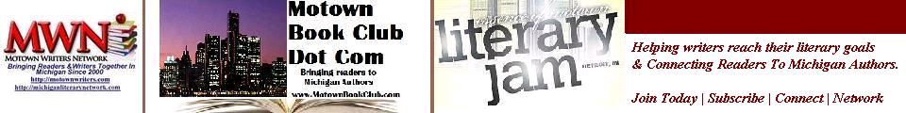
Facilitators, Partners and Event Hosts

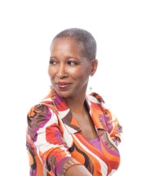Andrea Daniel is a lifelong poet. Her work has appeared in magazines and as part of an exhibit at a major metropolitan museum. When not writing poetry Andrea is a freelance writer for various publications and she has freelanced for an internationally distributed arts and entertainment magazine. She is co-owner/operator of Dakota Avenue West Publishing and is copywriter, editor and voice over artist for her own company, AND Communications. She had a 13-year career as production supervisor, producer, writer, reporter/talent with a local municipal government cable access channel, until her lay off in 2009.

Andrea is a member of the Motown Writers Network, and the Michigan Literary Network and is producer of the organization’s radio show on blogtalkradio.com. She also is a registered songwriter with BMI.
Like Gwendolyn, Andrea’s debut poetry book, epitomizes nearly forty years of her life as a poet. The first chapter, "Life, death, and stuff in between" is about just that, as Andrea or someone else has experienced or Andrea imagined. "Love and such," depicts love in its many forms. As a domestic violence survivor, she shares in “Abused Tales, poems written in the years of her recovery. "Love for Jay," the final chapter, are poems during frequent periods of separation from her (now adult) son in his early childhood years.
The legacy of poet Gwendolyn Brooks and the beauty of her work inspired the completion of Andrea’s book.
Andrea lives in Detroit, Michigan with her son and a sweet little Terrier-Poodle-mix named Dot.

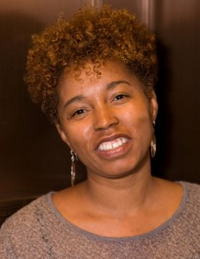Versandra Kennebrew after a 23 year career in retail reinvented herself and became a holistic health professional so she could provided her clients with holistic options for health and enhanced well-being. After more than a decade in the health industry, once again she reinvented herself and became a self improvement teacher studying mental health at Wayne County Community College District while being virtually mentored by various personal development gurus. She has touched the lives of thousands as a massage therapist, workshop facilitator, teacher and speaker. She hopes her most recent book will reignite the fire kindled by her first book, “Thank God for the Shelter: Memoirs of a homeless healer” and empower even more people around the world to ignite their imagination and discover the art of reinventing themselves.
Kennebrew is a self-proclaimed life changer. She believes this title best describes her purpose in life. As an elected Community Service Commissioner for the City of Detroit Department of Human Services her compassion and empathy for people who are underserved is put to work. A proud recipient of the Spirit of Detroit Award presented by the Detroit City Council in recognition of her leadership and commitment to enhance the quality of life of Detroiters, Kennebrew is a true community servant. In addition, the Detroit City Council has honored her with the Distinguished Service Award and Testimonial Resolutions for her involvement in National Hunger and Homeless Awareness Week and CAMP Lifesavers, a community health expo and workshops she sponsored to introduce Metro Detroit residents to the benefits of complementary and alternative medicine practitioners.
Channeling her creative energy to help others reinvent themselves is what she does and as a coach this creative energy develops products such as Social Media Made Easy and Map Your Success to provide ongoing support for authors and entrepreneurs. or more information about Versandra Kennebrew, Life Changer visit www.theartofreinventingyoubook.com, www.socialmediamadeeasydetroit.com & www.versandrakennebrewintl.com.

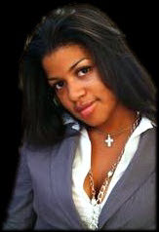Monica Marie Jones is an author, motivator and entrepreneur. Her published works include The Ups and Downs of Being Round Fiction/Self-help), Taste My Soul (Poetry), Floss (Urban Fiction), Swag (Fiction) and Sweet Soliloquy (Poetry). She has contributed to Chicken Soup for the Girls Soul, New Directions for Youth Development, 44th and Souls of My Young Sisters. She received her Bachelor’s degree in Elementary Education from Eastern Michigan University and her Masters of Social Work from the University of Michigan. Currently she resides in Detroit, Michigan where she operates her motivational speaking, training and consulting company, Inspirationista Ink LLC; her publishing and literary promotions company, The Literary Loft LLC; and her real estate investing company, Team JP Enterprises LLC, along with a partner. Visit her website at http://www.monicamariejones.com
Kai Mann is the author of 30 Day Notice; a novel published under her company Scriblical Vibez Publishing LLC. She is also an independent contract writer for Examiner.com where she holds the title of Detroit’s Best Friend Examiner. As a contributor to the poetry community, Kai’s online blog Kaiology Wet Your Intellectual Taste Buds is where she purposefully inspires thought pertaining to the themes of love, friendship, self-love, and self-progression. http://kai-mann.com & http://kaiologywetyourintellectualtastebuds.blogspot.com
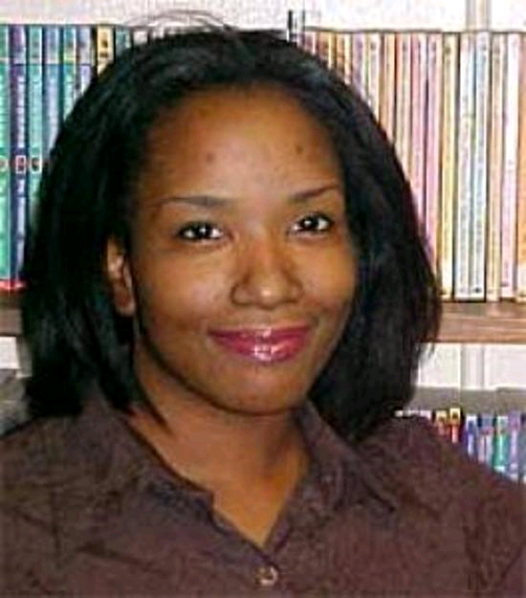Sylvia Hubbard knew she’d wanted to be a writer of romance long before she knew there were black writers in the world. Weaving stories magically as a summer past time to writing stories to get through the humdrum of school, she was able to create something from nothing.
Today, she has independently published over fourteen books, is the founder of Motown Writers Network and The AA Electronic Literary Network, CEO of HubBooks Literary Services, runs over five blogs on a variety of subjects, host and produces The Michigan Literary Network Radio Show and is a happily divorced mother of three children in Detroit, Michigan.
“I’m no superwoman,” she states with a smile that seems infinite on her lips. “I’m just being an asset in the world instead of a liability.”
Considered an addicted blogger by HoneyTechblog.com, nominated and recognized for her literary work in the Metro Detroit area, referred to as “A Literary Diva” by Detroit City Council and donned “Cliffhanger Queen” by her readers, she finds solace in speaking and educating on a variety of topics.
Her subjects range from Creative Intimacy, Single Parenting, Blogging, E-Books, Publishing (all aspects i.e.: writing, publishing, marketing & promoting online & offline), and personal triumphs with inspiration mixed in.
Never a disappointment, Sylvia Hubbard, has spoken in front of thousands all over the United States and Canada.

Vincent Alexandria is a nationally published author, who resides in Houston, Texas and was born and raised in Kansas City, Missouri. He is also an actor, producer, composer, lyricist, screenwriter, vocalist, and musician. He holds a Bachelor’s degree in Psychology from Rockhurst College and a Masters degree in literature from Baker University. Vincent is also the founder of the Brother 2 Brother Literary Symposium. He has completed four award winning murder detective mystery novels and has signed national book contracts with BET/Harlequin-Kimani Press for the titles; Black Rain, Black Heat, Black Vice, If Walls Could Talk, Postal Blues, Ain’t Nothing Like Loving an Ugly Woman, and Love Don’t Come Easy, with Parker Publishing. His novels, If Walls Could Talk and Black Rain, are in negotiations for movie options.
Vincent has a children’s book series entitled, Marvelous Marin and the Case of Mr. Bean, and Marvelous Martin and the Case of Freddy Freeman and the Freckled Faced Bully, which has been picked up by Marimba Books Publishing (Kensington).
He completed his award winning poetry book, Poetry from the Bottom of My Heart and is working on his second volume of work.
He is part of the anthology by Donna Hill, On the Line and Crimes of Passion, by Literary Wonders and Yolanda Johnson. He has won awards for Volunteer of the Year with the Boys and Girls Club of Kansas City, Missouri and the YMCA of Greater Houston Minority Achievers Award.

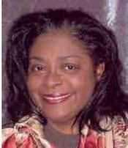Karen White-Owens is a lifelong resident of Detroit, Michigan. She earned a bachelor's degree in sociology and master of Library and Information Science from Wayne State University. In addition to writing, she is the director of the Lenox Township Library.
Ms. Owens is the author of nine romance novels and two novellas. Her 2004 novel, Circles of Love received a 4-1/2 Gold review from Romantic Times Book Club, the highest honor an author can receive and was nominated Best Multicultural Novel for 2004. Love Changes Everything received 4-1/2 stars Romantic Times Book Club and top pick for November 2005. I Can Make You Love Me was released October 6, 2009 followed by You're All I Need in 2010.
Other Facilitators, Moderators & Volunteers: Judy Seabury, Walter O’Bryant, Cliffton Hubbard, Octavia Lesley, Cassandra Carter, Phette Ogburn, Johnnie Jenkins, Andre Royster, Kelly Green, Michael Collins, Victor Walker

Passion Fruit Festival 7.0
The seventh annual Passion Fruit Festival is The EchoVerse journey through erotic visual verse. An annual festival that showcases the creativity of notable and emerging poets, musicians, performance, visual and literary artist from Southeast Michigan and beyond. In 2011, Passion Fruit Festival 7.0 will be held in The Knight Suite of the Virgil H. Carr Cultural Arts Center in Detroit’s Paradise Valley (Harmonie Park).

Featuring: The Naked Muse with Aural SassS and JyObadele, Inohs Sivad, and DJ SoundCircle with special guest performances by The Oracle (Dimonique Boyde), Jeff Nelson, ONE (Lonnie Hamilton).
Each year selected performance and visual artist are invited to provide cutting edge and experimental art that explores eroticism. These artist are encouraged to use Passion Fruit to expand boundaries, which makes the show only appropriate for mature audiences (18+). This year will include feature performances by noted local musician Inohs Sivad, and a special performance of The Naked Muse by Aural SassS and Johnny Jenkins Jr. (JyObadele).
Spotlight performances provided by local poet Dimonique Boyd (The Oracle), with L. Jermaine and Jeff Nelson who have both served on Detroit Poetry Slam Teams. This year's festival is produced in association with the Motown Writers Network's 2011 Essence of Motown Literary Jam and Conference.
http://motownwriters.com/
Passion Fruit Festival 7.0 will be hosted by local poet JyObadele, with smooth soul and house provided by DJ Andre Roysters of SoundCircle DJ's Additional information and tickets available via www.TheEchoVerseVibe.com.

Celebrating The Written Word one reader & writer at a time. Support, Strengthen and Subscribe!

ARTS LEAGUE OF MICHIGAN
VIRGIL H. CARR CULTURAL ARTS CENTER EXECUTIVE SUMMARY
The Arts League of Michigan (ALM) is a center that develops, promotes, presents and preserves the African and African American cultural arts traditions within our multicultural community. Over the years, ALM has offered a wide array of programs, services and activities for both artists and audiences.

The development of the Virgil H. Carr Cultural Arts Center is the next step in the evolution of the organization and moves to establish it and ALM as major participants in the cultural life of our community and the nation. Named in honor of Virgil H. Carr, past Chairman of the Board of Trustees of the Arts League of Michigan, this facility will be recognized as the premier center for African and African American cultural arts programs and activities in the nation.
While many other organizations strive to serve and provide the community with African American cultural arts programs and services intermittently, the Carr Center will offer the community continuing year-round activities designed to reach and serve the city of Detroit and the region. Most meaningfully, the Center has far reaching capacity to uplift the citizens of Detroit—where the population exceeds 85% African American. The Center provides a voice to tell the story, present and promote the work, and preserve the legacy of African American art—in all disciplines.
Downtown Detroit is in a state of tremendous development and the Carr Center is there as a catalyst for economic revitalization and community development. The case for the Center is integral to livability, economic vitality, downtown revitalization and the education and development of the best of our youth, helping make Detroit a point of destination.
The Harmonie Club, located at 311 E. Grand River is a perfect location for the Carr Center. Constructed in 1895, the building and its subsequent club, known as the Harmonie Club was originated by the Harmonie Society, a musical society of German immigrants. The club was a place offering fine dining, tavern, card rooms, bowling alley, lounges and musical events. The club was sold in 1974 and stood vacant until the late 1990’s, when a pub opened in 2000 utilizing only the basement of the building.
Designed in classical Beaux Arts style, the building is four stories embellished by appealing stone work, and carefully designed curving windows, all reminiscent of the best in urban architecture of the late Victorian age. A national registry of historic sites member, its location is pivotal to a morphing downtown characterized by new restaurants, established ones enjoying increases in business, older building renovations, and new ones being proposed.
An art-infused community has impact on the livability, vitality and quality of life of a region. The Carr Center will leave an enduring imprint on the landscape of Detroit by making our city a connected, creative community, recognizing the importance of art and culture to a vibrant economy and society. It is ALM’s objective to be a definitive player in Detroit’s revitalization efforts—helping make Detroit a “Cool City” in which to live, work and play.
FOR MORE INFORMATION, CONTACT:
Oliver Ragsdale, Jr., President
Arts League of Michigan
Phone: (313) 965-8430 * Email: oliver@Artsleague.com
Workshop Descriptions


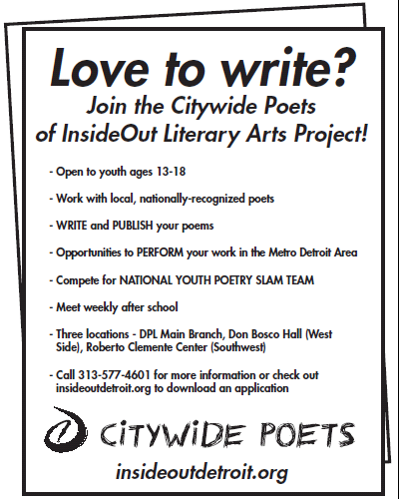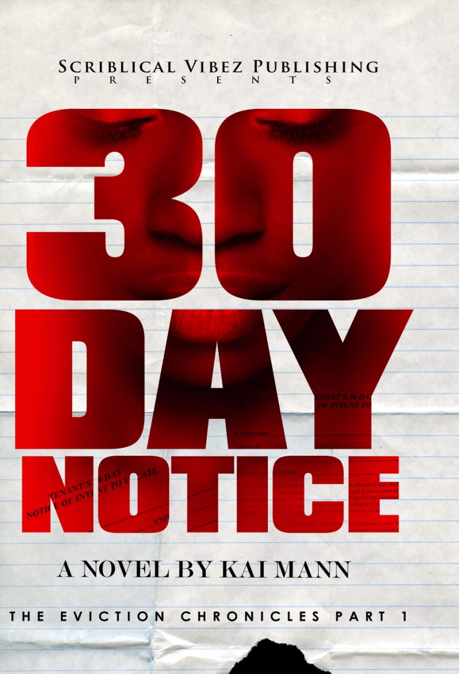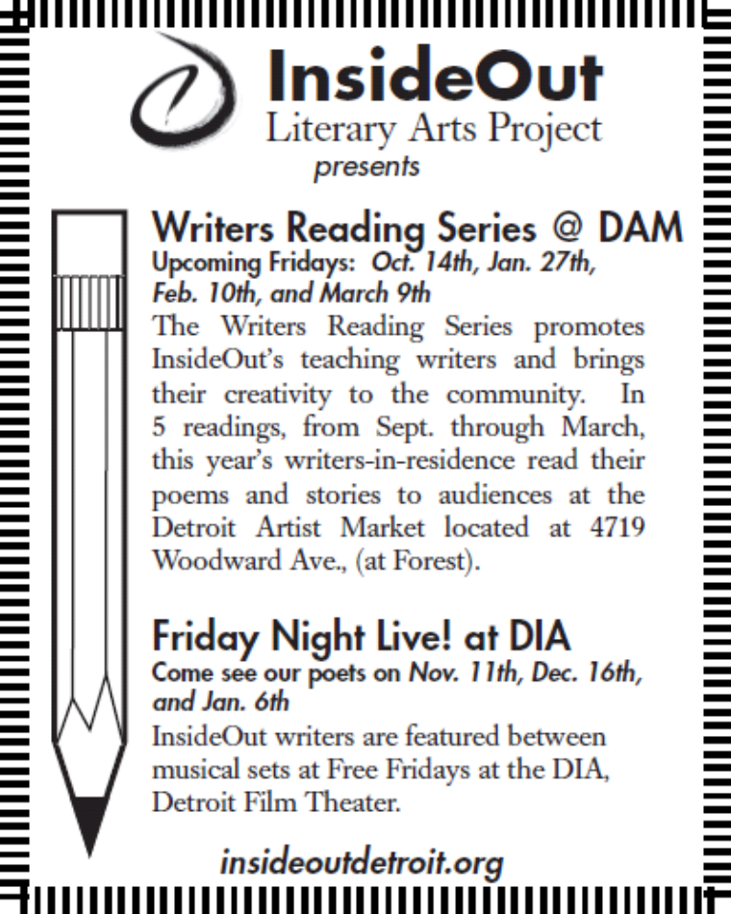
NEW RELEASE:
“Lancaster Lion” Speaks On Cooperation In A World Full Of Chaos

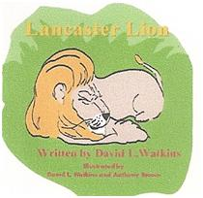

In the second installment of the Growing Up Series, David L. Watkins introduces Lancaster Lion, who thinks he should be in charge because of tradition. Lancaster and his friends learn that by working side by side and using their own Individual talents they can save their jungle home. The new book “Lancaster Lion,” ($11.95) helps parents, educators and communities teach children the importance of cooperation—working together for the survival of us all.

The Growing Up Series features books that provide readers with lessons about courage, cooperation, respect,
pride, loyalty, honesty and kindness. The first book, “Benny and the Basketball Bully” ($10.00) speaks on courage. Benny, an 11-year-old boy, is challenged by an older child for the way he eats, speaks and dresses. Benny retreats and hides until the bully crosses a boundary by challenging Benny’s belief system, forcing him to make a stand.

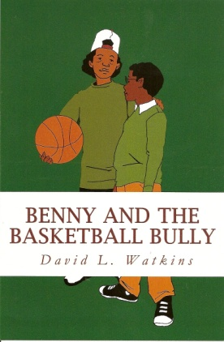

For more information or to place orders for the books, send an email to
davidwatkins10@comcast.net , visit www.booksbydavidwatkins.com or Facebook
Send written inquiries to: David Watkins, P.O. 39082, Redford, MI 48239.
Call (313) 443-5181.

NOTES/CONTACTS
__________________________________________________________________________________________

__________________________________________________________________________________________

__________________________________________________________________________________________

__________________________________________________________________________________________

__________________________________________________________________________________________

__________________________________________________________________________________________

__________________________________________________________________________________________

__________________________________________________________________________________________

__________________________________________________________________________________________

__________________________________________________________________________________________

__________________________________________________________________________________________

__________________________________________________________________________________________

__________________________________________________________________________________________

__________________________________________________________________________________________
NOTES/CONTACTS
__________________________________________________________________________________________

__________________________________________________________________________________________

__________________________________________________________________________________________

__________________________________________________________________________________________

__________________________________________________________________________________________

__________________________________________________________________________________________

__________________________________________________________________________________________

__________________________________________________________________________________________

__________________________________________________________________________________________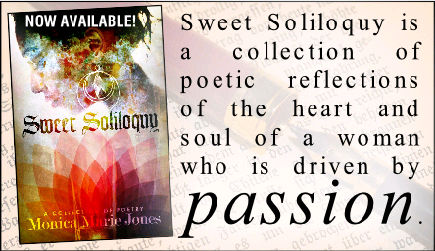

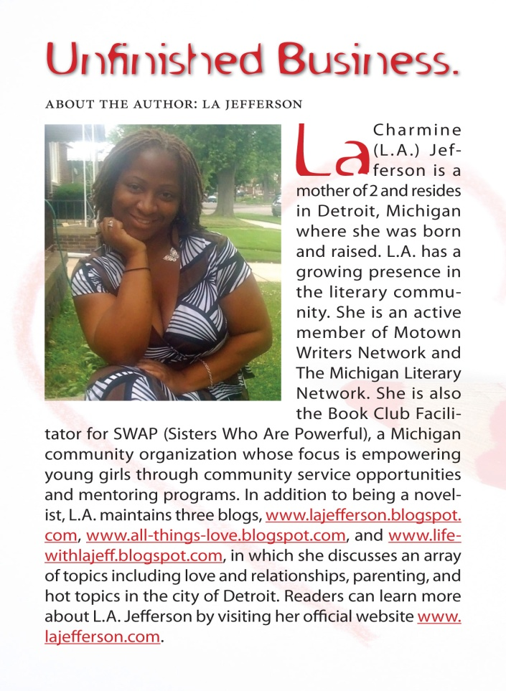

Todd Russell Perkins, Esq., Lawyer
Practice Areas:
*Criminal Law
*Civil Litigation
*Entertainment Law
*Advise & Consult Entertainment Upstarts & Established Artists
*Label Development
Education:
*University of Detroit Jesuit High School, 1988
*Dartmouth College, 1992
*University of Detroit-Mercy Law School, J.D., 1996
Biography:
Todd Perkins was born and resides in Detroit Michigan. He is a partner with Perkins & Inniss, PLLC. He focuses his practice on criminal/civil litigation and entertainment law. He is also an Adjunct Professor at the University of Detroit-Mercy Law School. His community activities include the City of Detroit Board of Ethics – 2007–Present; Northend Angels Night Cookout – 2003–Present; and Northend Cookout and Community Events – 2002 – Present.
Representative Clients:
*Artist Management – END Management
*TRP Management, LLC
*My Daddy’s Records, Inc. – Indie Label
*Potbelly Publishing – Indie Publisher
*Perk Promos, LLC – Party/Concert Promotion
*Kilimanjaro Management – Asset Management/Investments
If you are in need of legal assistance in any of these areas, look no further. Our attorneys have the expertise to assist you. We welcome the opportunity to speak with you about your legal issue.
Full page

